3rd FLORIDA/35th MASSACHUSETTS HERITAGE, INC.
Respect and Honor



.

CAPTAINS LETTER, January 2011 - To the new Recruit
Now it begins, the 150th Anniversary of the War Between the States. The 3rd Fl/35 Mass is ready to take to the field. Are you?

Will you be a serious participant and join the “company “and start putting together your own “kit” and become involved?

The “company” has made it possible for those who wish to stand with us to do so. Yet, it must be understood that individual responsibility, initiative and dedication plays a vital role if you are to become a serious Civil War Re-enactor and take some ownership in the Company. Our mission is to provide a path to the “life and times of the Civil War Soldier “. It is you, the recruit,that must step up and follow that path and improve your soldier’s impression thus improving the Company.

We want the experience to be educational, enjoyable but also reflective. The war was long, arduous, and more painful than your generation can ever imagine. I want you to appreciate the sacrifice and courage of those men you portray and to honor with reverence their memory.
When you feel the fatigue of the march as the musket grows heavy on your shoulder, when you down your last drop of water from your canteen on a hot and dusty day, when you shiver in your blanket during a freezing night, huddle in a dog tent during a down pour, hear the din of battle until your ears ring and you look across the battlefield and see a wall of men coming at you - and you say with unfeigned conviction “Thank God, I did not have to do this for real”. And yet, you walk away with the feeling of pride and accomplishment and a connection with those soldiers long gone. That is the essence of the Mission, for you have just received a small taste of what it was like to be a soldier in the 1860s.
See you on the field of Honor – Captain Short

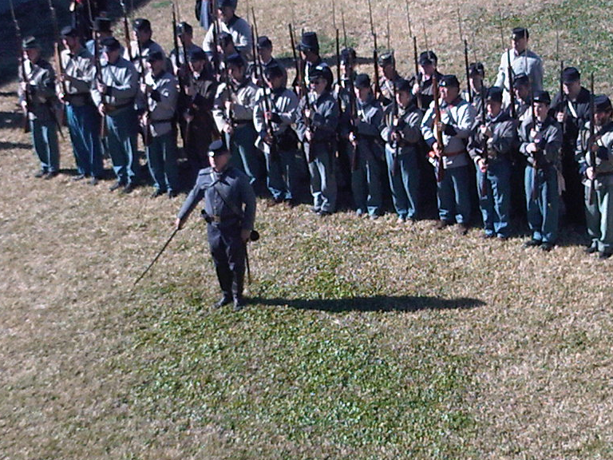

Please accept and pass on my personal and professional thanks for the
outstanding job the 3rd did on the very successful first of the 150th
anniversary events that NPS will be hosting over the next four years. You
guys did an excellent job all around and I commend you, we received
positive feedback from the public and our staff. I am confident that next
year we will be hosting the federal retaking of the fort and we certainly
want the 3rd/35th to be at the forefront.

Jeffrey Edel
U. S. Park Ranger
Historic Weapons Supervisor
Castillo de San Marcos National Monument

Visit our New Website for 3rd Fl /35 Mass Heritage Inc. http-3rdfloridainfantrycsa.yolasite.com.

Uniforms and Weapons Request_: If you have a friend that would like to try Re enacting, please let me know at least one week prior the event. This will ensure that we have enough uniforms, powder, and equipment to meet the need. For just a $25.00 donation to the Company, a novice can be fully outfitted to experience Civil War Living History. We have enough equipment to fully equip 20 soldiers. Let us try to fill each one at every event. We also have 7 tents available too.

Medal of Honor Recognition: Although it was created for the Civil War, the US Congress made the Medal of Honor a permanent decoration in 1863. In addition the Confederate Congress on October 13, 1862 passed a similar act to establish a Medal of Honor for Confederate Soldiers.
It will become a company tradition to call out at least one name of a Metal of Honor recipient at each role call. When the name is called out the entire company will respond with “here in spirit First Sgt “. We do this not for them, but for us. For we are the poorer, if we do not honor them.
Capt. Short

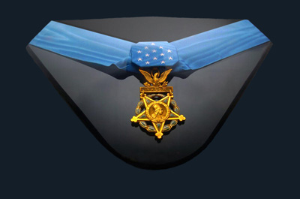
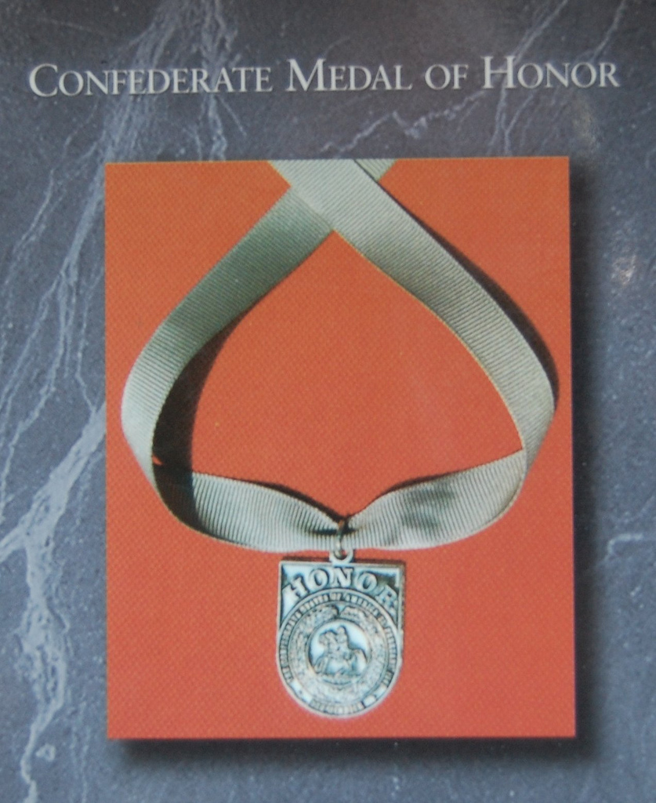
Cartridges available at each event: Jeff Mathis continues to provide pre-rolled cartridges for members of the company. This provides an enormous service for all of us and helps put money in the treasury. The cartridges are prepackaged 40 round per pack at $5.00. So if you forget to roll your own cartridges or just wish to take advantage of the convenience that Jeff provides , be assured that rounds will be available.
Dues and Insurance fees are due at Olustee: $10.00 for dues and $10.00 for insurance. Family membership is 20.00 plus $10.00 for insurance for each family member fighting on the field.
Payment by CHECK (if possible) at the Battle of Olustee. Make Check out to 3rd Fl/35 Mass. Heritage Inc. 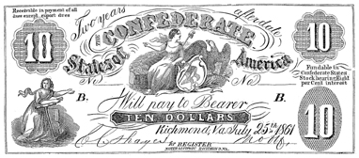
________________________________________________________________________
Dog Tags: If you wish to purchase a period style dog tag (metal disc with a chain) we will be taking orders at Olustee. The dog tag will have your name and the Company’s name and number. On the back of the tag a sticker will be applied to indicate if you have purchased insurance. Thus you will not have to carry your insurance card on the Battlefield. The Dog Tags will be $3.00.
Beginning this year all reenacting participants at State & National Parks Events must be 16 years old to fire a rifle musket. Those under the age can participate in the battle but will not be allowed to shoot.
Remember, this is only for those events under State or Federal Control. All other events the age remains 15 years old unless otherwise advised.

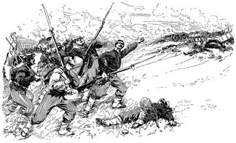

Battle Plan

January 29: Special Civil War Exhibit at Gold Head State Park near Camp Blanding , just south of Orange Park Fl . This will be a one day event where we can set up a Recruiting Booth and Promote the Company to the Orange Park and Jacksonville Public. If you are interested in helping out call Captain Short – cell: 904-403-8225 or home ph: 904-291-3014

February 18, 19, 20, 2011. The Battle of Olustee reenactment, parade and Living History. Olustee Battlefield State Historic Site, Olustee, Florida. Your help is needed with the school day programs on Friday, February 18. The reenactment takes place on the actual site where the Battle of Olustee (Ocean Pond) was fought. Visit with thousands of Civil War reenactors, tour the camps, see demonstrations of all types. Best gathering of Civil War sutlers at any Civil War event with 80+ sutlers in attendance. Friday is School Day. Battles Saturday and Sunday. Full scale artillery only. The Olustee Battle Festival Parade will begin at 10:30 AM. Reenactors are encouraged to participate. Buses will transport reenactors to and from the parade site and will be served breakfast. No pets. Due to concerns for public safety, no fur bearing animals such as cats and dogs will be allowed during the reenactment activities. This does not apply to horses. Get there early. The crowd gets big fast, sign-in and parking can be a hassle. First time visitors and reenactors to the event should read the listing of activities at http://battleofolustee.org/ The battlefield is located just fifteen miles east of Lake City on Hwy. 90 from I-75 and 50 miles west of Jacksonville. Take I-75 to Hwy. 90 exit. Go east on Hwy. 90 . Contact the Olustee Battlefield Historic Site at (386) 758-0400 or email olusteecso@yahoo.com

February 26: After seeing the 3rd Fla ‘s performance at Fort Marion , the Company has been invited to participate in a Time Line Event at the Fountain of Youth in St. Augustine. This will be a one day event. This will be another opportunity to promote the Company and recruit. . If you are interested in helping out call Captain Short – cell: 904-403-8225 or home ph: 904-291-3014

March 4, 5, 6, 2011. The Battle of Natural Bridge. Natural Bridge Battlefield State Historic Site (Florida). Activities throughout the day including Civil War military drill and camp life in the Military Camp. Civilian Camp will feature sewing, spinning, knitting, needlework, candle making, and other Soldier Aid Society activities. A formal midmorning Ladies Tea will be held on Saturday. A full military skirmish will be conducted on Saturday afternoon. On Sunday, camps will be open to the public at 9:00 AM. At approximately 1:00 PM, opening ceremonies will honor the combatants of the Battle of Natural Bridge which will immediately be followed by the Battle of Natural Bridge reenactment. Directions: Drive south from Tallahassee for about eight miles to the community of Woodville. As you reach the elementary school at the southern edge of Woodville, turn left onto Natural Bridge Road. Travel approximately six miles east to the battlefield site. Authentic soldiers and civilians contact Captain Chris Ellrich at cellrich@hotmail.com Artillery by invitation only. Authentic sutlers (by invitation only) contact John Boger at jboger@nbhscso.com Please direct all other inquires to Bob Trapp at btrapp@nbhscso.com

March 19, 20, 2011. 150th Anniversary Secession Garrison at Fort Clinch. This event will commemorate the commandeering of the fort by local militia forces shortly after Florida secedes from the Union. Meals provided for a fee to cover the cost (aprox. $10 to $15). Interested units and individuals, contact Lt. Willie Evans at uw6165@aol.com

March 25, 26, 27, 2011. Battle at Narcoossee Mill. St. Cloud Fla. (southeast of Orlando - Kissimmee St. Cloud area. Sponsored by the Jacob Summerlin Camp #1516 Sons of Confederate Veterans. The Battlefield is on 150 acres of open and wooded land on the shore of East Lake Tohopekaliga. The event host will be checking coggins papers for horses at the registration desk. A reenactor entrance fee of $3 per person will be collected at the registration desk. A sutler fee of $25 will be charged to all sutlers. Limited sutler electrical hook-ups are available for an additional fee. Friday, the 25th, is education day which begins at 9:00am; re-enactors are needed to provide demonstrations. A lunch will be provided for volunteers assisting with the school program. There will be a ladies tea Saturday morning and military ball on Saturday night. The park is located at 4700 Chisholm Park Trail, St. Cloud, Florida 34771. Take Hwy 192 (Irlo Bronson Hwy) to Hwy 15. Go 2mi North on Hwy 15, look for the park sign. Another way to get there (from the North) is to take I-4 to the toll road 528 (Beachline Expressway) go east and get off on Hwy 15 exit (Narcoossee Road) go South on Hwy 15. Another way if you are coming from the Florida Turnpike, get off at exit #244 and go east on Hwy 192 through St. Cloud, then turn North on Hwy 15 (Narcoossee Road). GPS position: N28.16.448 W081.15.020 Contact the SCV Camp at http://www.jacobsummerlin.org/ or Don Williams at warthog1146@aol.com More information, pre-registration http://www.jacobsummerlin.org/ed2007.pdf

Battalion Muster will be held at the Dade Battlefield in May 14th 2011. No uniforms required but bring your rifle

The Sesquicentennial Begins – The 150th Anniversary of the Battle of Bull Run – First Manassas
Join us July 21 through July 24, 2011 to commemorate the 150th Sesquicentennial of the American Civil War and the Battle of First Manassas (Bull Run) in Old Town Manassas, Virginia. This 4 day event will feature living history demonstrations, speakers, art, music, and many other historical commemorations and activities for the family.

Note : The 150th Anniversary Battle of Shiloh MARCH 30TH – APRIL 1ST 2012 –www.armiesoftennessee.com

Battalion 2010, 2011 schedule (as of this writing);

February 18-20, 2011; Battle of Olustee, Ocean Pond, Fl.
http://battleofolustee.org/reenactment.html

March 5-6, 2011; Battle of Natural Bridge, Near Tallahassee, Fl. (Sponsored by Leon Rifles and CSO)
http://www.nbhscso.com/gpage1.html

March 19-20 2011; Fort Clinch Secession Garrison, Fernandina Beach, Fl. (Sponsored by 7th Florida
http://www.floridastateparks.org/fortclinch/March 25-27; Battle At Narcoossee Mill, Narcoossee, Fl.
http://jacobsummerlin.org/

April 8-17, 2011; 150th Firing on Fort Sumpter, Charleston, South Carolina.
http://claudesinclair.com/Palmetto-Batallion/Firing-on-Fort-Sumter-home-page.html

July 21-24, 2011; Battle of First Manassas, Manassas, Virginia.
http://www.manassascivilwar.org/

Other Florida events;
February 5-6; Camp Milton; The Road to Olustee, Camp Milton, Jacksonville, Fl.
A living history (Sponsored by the 3rd Florida Co. 'A')
Please email Capt. Dennis Short for additional Information at dennisshort@bellsouth.net

Future Events to consider.....

150th Anniversary Battle of Shiloh
—A Blue Gray Alliance Event
—March 31- April 2, 2012
—Land already acquired
—Immediately adjacent to the Shiloh National Military Park

150th Anniversary Battle of Chickamauga
—Atlanta Campaign, Inc. will handle all of the logistical work for the event
—Blue Gray Alliance will assume military command
—Possible event date of September 21-22, 2013
—Same site as the 145th
—City of Chickamauga looking forward to the event

150th Resaca
Date and specifics to be determined

150th Franklin
—Presented by Col. Joe Grosson (Cleburnes)
—In the planning stages
—Working closely with local Franklin organizations
—A Blue Gray Alliance military command

150th Mill Springs
—Presentation made by Col. David Neal on behalf of Gen. Rambo—
—Suggested event on anniversary date if anyone was interested
—January event date in Kentucky
—January 20-21, 2012
—Interest in the event being sought as well as further input

150th Perryville
—Slide show presented
—October 2012 event date

150th 1st Manasas
—Presented by Gen. Jenette, ANV
—July 2011
—1000 acre battlefield
—Federal Commander will be Gen. Tony Daniels (USV)

150th Gettysburg
—Presented by Gen. Dave Cornett—
—Working on land deals to secure expanded areas
—Federal commander will be Allen Baldwin

150th Spotsylvania
—Presented by Gen. Cornett – Longstreet’s Corp
—Future events will be ran by county and not outside organizers
—Working to make it a larger event and better event
—Dual sites for the 150th , one infantry and one cavalry site
—Will run two events at once on same weekend

150th Wilderness Campaign
To be determined

150th Cedar Creek
To be determined

150th Bentonville
—Invitation only event
—2015 date
—Original ground
—Original numbers

2015 Appomattox
To be determined

____________________________________________________________

Dennis Short

Home Phone: 904-291-3014
Cell Phone: 904-403-8225

